**LESSON: "משיב הרוח ומוריד הגשם"**

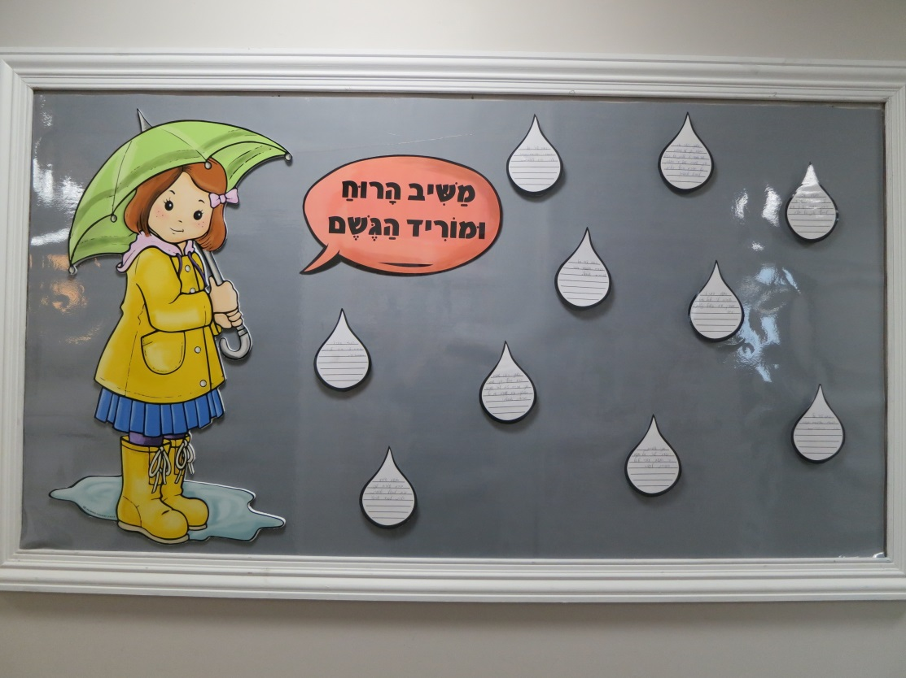

We begin to say “משיב הרוח ומוריד הגשם” when reciting מוסף on שמיני עצרת. We continue to say משיב הרוח throughout the winter. This is the most opportune time for your students to discover the wonders of rain, and to learn to appreciate the blessing that rain gives all of us in our lives.

Begin your lesson with a mashal that will clarify your lesson’s objective, and will bring the concept of Hakaras Hatov down to your students’ level.

**Mashal #1**: Chani was eagerly looking forward to Chanukah this year more than ever. She was going to become Bas Mitzvah on Chanukah, and she was very proud of reaching this milestone!

Chani’s mother hosted the family Chanukah party that year. All of Chani’s aunts, uncles and cousins came to celebrate. Chani stood at the door and greeted all of the guests. How lucky she was that so many of her relatives remembered that it was her Bas Mitzvah birthday! They wished her mazel tov as they walked in, and handed her special gifts; a leather-bound Tehillim, a bracelet, and a cute wristlet. How thoughtful of them!

There was just one problem. Chani was so preoccupied with everything happening at the Chanukah party that she forgot to thank her relatives for the gifts before they left. How do you think her aunts felt about her not acknowledging the gifts?

Chani should have shown her aunts appreciation for their thoughtfulness. It would have been the right thing to do…

**Mashal #2**: A lady was driving on the highway when she suddenly had a tire blowout. She quickly pulled over to the side of the road and got out of her car. She looked at her watch and realized that in less than ten minutes her little boy would be dropped off at his bus stop and would be waiting for her to take him off the bus. The lady was standing at the roadside, trying to figure out how she could get home in time for her son. At the same time, a yeshivah bachur was driving on the opposite side of the highway when he noticed the lady standing near her car on the roadside, appearing to need help. He made a U Turn, and drove up to the lady to ask if she needs help. She explained what a rush she was in. She could attend to the car later. The bachur offered her a ride to the bus stop, and she made it just in time. She asked him his name, said thank you, and ran to her destination!

Two days later, on Erev Shabbos, the lady sent a candy platter to the bachur’s family as a token of Hakoras Hatov for helping her out when she was stranded on the highway! Such was this lady’s appreciation for this small act of kindness.

**Nimshal:** We must realize what a tremendous chesed Hashem does for us by making rain fall from the sky. There is no greater chesed than Hashem opening the heavens and sending rain upon the earth. This rainwater sustains all life in this world; humanity, animals, fish, birds, trees, plants, flowers, etc. We should always be cognizant of this huge miracle that Hashem, in his kindness, does for us all the time! Waking up to a rainy day should be a reason to celebrate and to give a שבח והודאה to Hashem for “showering” us with the brocha of rain!

This is the reason why our חכמים added "משיב הרוח ומוריד הגשם" to our daily tefillos. We must thank Hashem for His rain on a daily basis! Rain is a gift from Hashem for which we must be grateful at all times.

The גמרא in תענית says: "גדול יום הגשמים כיום שנתנה בו התורה...". The day that rain falls is as great as the day of מתן תורה.

"הודו לה' כי טוב"- Let it become second nature for us to constantly be aware of Hashem’s kindness to us. It is so easy for us to take for granted everything that He gives us.

Thank you Hashem for the rain!!

**SUGGESTED WRITINGS FOR THE GESHEM BULLETIN BOARD:**

This bulletin board includes blank, lined raindrops that can be used for student writings. Below are some suggestions for writing topics that you can give your students:

* **What are my thoughts when I see that it is raining?**
* **Why I Thank Hashem for Rain…**
* **What Rain Means to Me…**

**INSPIRATIONAL STORIES ABOUT RAIN:**

Below are two famous stories about rain that you can share with your students. They are interesting and inspiring and will remain etched in their memories.

****

Prior to the  of Rav Aharon Kotler , there was an unusually serious drought in . The rain season had arrived, but sixty days of this season had passed without a drop of rain! The sun continued to shine and the temperatures remained unusually high. Many special  for rain were being said in shuls and  across . The situation was extremely desperate and a tremendous  was needed.

There is a special  for rain. A special wet cloth is tied to the hand of a great  at the time of his . It was decided by  on the day of Rav Aharon Kotler’s that this should be used, as the need for a was very great. A special wet cloth was tied to Rav Aharon’s right hand before the .

Amazingly, hours after the  on , a very welcome change of weather took place. The skies darkened. Thick clouds appeared. A forceful rain fell across . The occurred in the  of Rav Aharon Kotler !

(This story of the “miracle” of rain is told and retold. Both Rav Eli Ber Wachtfogel  and Rav Tzvi Yosef Bursztyn  were in  at the time that this story took place.)

**The story of חוני המעגל:**

There was once a drought in Eretz Yisroel during the time of the Bais Hamikdash. An entire Fall and Winter season went by without any rain falling. Now it was already the month of Adar and it still did not rain! There was almost no food left to eat and no water to drink. The plants had died. There were no fruits, vegetables or grains growing. The people in Eretz Yisroel were very desperate for a salvation from this terrible drought.

The חכמים made aתענית and a יום תפילה. All of Klal Yisroel fasted and davened for rain, yet the rain did not come.

A great tzaddik lived in Yerushalayim at that time by the name of Choni. Theחכמים went to Choni and asked him to daven to Hashem for rain. They hoped that Hashem would have rachmanus on his Nation and would accept the tefillos of this great tzaddik!

Choni agreed to daven to Hashem for rain. He first did something very interesting. Choni drew a circle on the ground. He then stood inside the circle and began to plead to Hashem: “Ribbono shel Olam! Your children are desperate for rain to fall. They have asked me to daven on their behalf because they know how close to You I am, and how You very often have granted my tefillos. I will not move myself out of this circle until You send rain to Eretz Yisroel!”

Immediately, rain began to fall – small droplets of rain that just about made the ground a bit wet.

The people came back to Choni and asked him to daven to Hashem again for stronger rain that would fill the wells with water and would fully saturate the dry parched land across Eretz Yisroel.

Immediately, strong rains began to fall, so strong, that the trees and houses were almost falling down!

The people ran back to Choni and begged him to ask Hashem for “normal” rain, for גשמי ברכה.

Choni again davened to Hashem and asked for rain that would satisfy everyone in Eretz Yisroel.

Sure enough, Hashem listened to Choni’s tefillos and sent steady, pleasant rain upon Eretz Yisroel. The wells were filling up with water and the ground was drinking in every drop of rain. Yet, it just did not stop raining! After some time, the people in Eretz Yisroel were very scared that the constant rain would cause serious flooding in the valleys of Yerushalayim and in their homes. They once again went to the tzaddik Choni and asked him to daven and beg Hashem to make it stop raining already.

Choni turned to his people and said: “It would be a good idea for all of Klal Yisroel to bring a korban to Hashem to thank Him for all the rain that He sent. If you do that, I will then daven to Hashem and ask Him to end the rain. “

Korbanos of thanks were brought to Hashem. Choni then davened and asked Hashem to make the rain stop. Immediately, the winds stopped blowing, the clouds dispersed, the rain stopped, and the sun began to shine!

Choni became known as **“Choni Hameagel” – חוני המעגל**, because of the “circle” that he drew on the ground and stood in when he davened to Hashem for rain!

_______________________________________________